***CT0357919 – Shi Kaixing***

**Introduction**

Sands Lodge is the name of Airbnb room rental company .It was established in 2021 by a young couple who love travel . Sands Lodge is located at Canyonlands national park in Utah ,America. It was one of the most unique Airbnb rental rooms in USA. The owner has two types rental rooms for travelers to choose which are dome house and motorhome. They are just two hundred meters away from each other . The concept of Sands Lodge is inspired by natural wonderland in desert . As we know people have been depressed by the covid-19 pandemics for two years, most of them want to leave the hustle and bustle of the city and travel to a peaceful place to relax. Sands Lodge will be one of the best staycation choices when you travel to somewhere like desert .You can stay in domes or motorhomes to enjoy the wonderful mountain and desert views instead of staying in hustle hotel rooms. The property also provide cooling and heating system for four-season use. Our value is to make all visitors who stays in our rooms would have the unforgettable memories.

**Current System**

Sands Lodge was established in 2021 by the young couple , since they just started their own small business , they do not have their own website now. Most of the customers book the room by phone calling or email , it is troublesome for them. Hence, they would like to create their own websites for room booking .It will make things easier and more convenient for both house owner and guests.

**Objectives**

Web pages are designed to make it easier for customers to book rooms before they travel, which also save lots of time for house owner on answering calls and checking emails. Brand new designed web page contains of gallery of the property , which allow people get better understanding of the property itself , and get more information via pictures post online before they travel . Address of the property will also indicate on specific page , which enable guests to follow the best route to get there.

**Page Specification**

1. **Home page:**

Home page always to be one of the most page among all the pages , the conception of this Airbnb rooms are illustrated in the home page. When you visit the home page, the first sight you will see would be the slide images of Canyonlands National Park where our rental properties locate at .At the same time , you will be the two pictures of our accommodation which are Dome house and Motorhome . There is one YouTube video about dome house in home page as well .

1. **About page:**

There are three modules introduced in this page, which are about us , our stories and our services . It renders some important message for guests to get better knowledge of the rental property itself as well as the house owner’s stories and expectation of their rental properties.

1. **Dome house page:**

This page introduce one of our rental properties named Dome house .At this page, there are several images of dome house inserted to show the inner decoration of the house .The page deliver the information about what amenities we have in our Dome house and important things that our guests need to take note.

1. **Motorhome page:**

Same as Dome house page , this webpage introduce another property at Canyonlands, some slide images are inserted to better illustrate our unique rental space. Introducing some outdoor and indoor amenities we can provide for our guests. As well as some important message that guests should know before checking in.

1. **Contact page:**

Contact page create web form for guests’ feedback ,enquiry or special request.

Apart from that ,this page also include our contact information, such as phone number ,email and address of our two rental houses.

1. **Book Now page:**

Book now page is for guest to book rooms online . There are two forms in

this page. Reservation form require guests’ personal information and booking information while price and information form illustrate the room fare , bed size

information and pick up service charge if needed.

**Site Map**

BOOK NOW

CONTACT

MOTORHOME

DOME HOUSE

HOME

ABOUT

**Prototype**

Home Page

Hyperlink1 Hyperlink2 Hyperlink3 Hyperlink4 Hyperlink5 Hyperlink6

Heading

Image slider

Heading 1

Video

Paragraph1

Heading 2

Image 2

Image 1

Audio player

Paragraph 3

Paragraph 2

Footer

Social media icons

copyright

|  |  |  |
| --- | --- | --- |
| Field | Description | Data Type |
| Heading | Company name | Text |
| Hyperlink 1 | Hyperlink to home page | Hyperlink |
| Hyperlink 2 | Hyperlink to about page | Hyperlink |
| Hyperlink 3 | Hyperlink to Dome house page | Hyperlink |
| Hyperlink 4 | Hyperlink to Motorhome page | Hyperlink |
| Hyperlink 5 | Hyperlink to contact page | Hyperlink |
| Hyperlink 6 | Hyperlink to book now page | Hyperlink |
| Image slider | Auto image slider | JPG image |
| Heading 1 | Conception of company | Text |
| Paragraph 1 | Introduction to the concept | Text |
| Video | YouTube video | video |
| Heading 2 | Accommodation | Text |
| Image 1 | Picture of Dome house | JPEG Image |
| Image 2 | Picture of Motorhome | JFIF Image |
| Paragraph 2 | Text description for Dome house | Text |
| Paragraph 3 | Text description for Motorhome | Text |
| Audio player | Background audio for home page | Mp3 |
| Footer | Social media icons and copyright . | Icons and text |

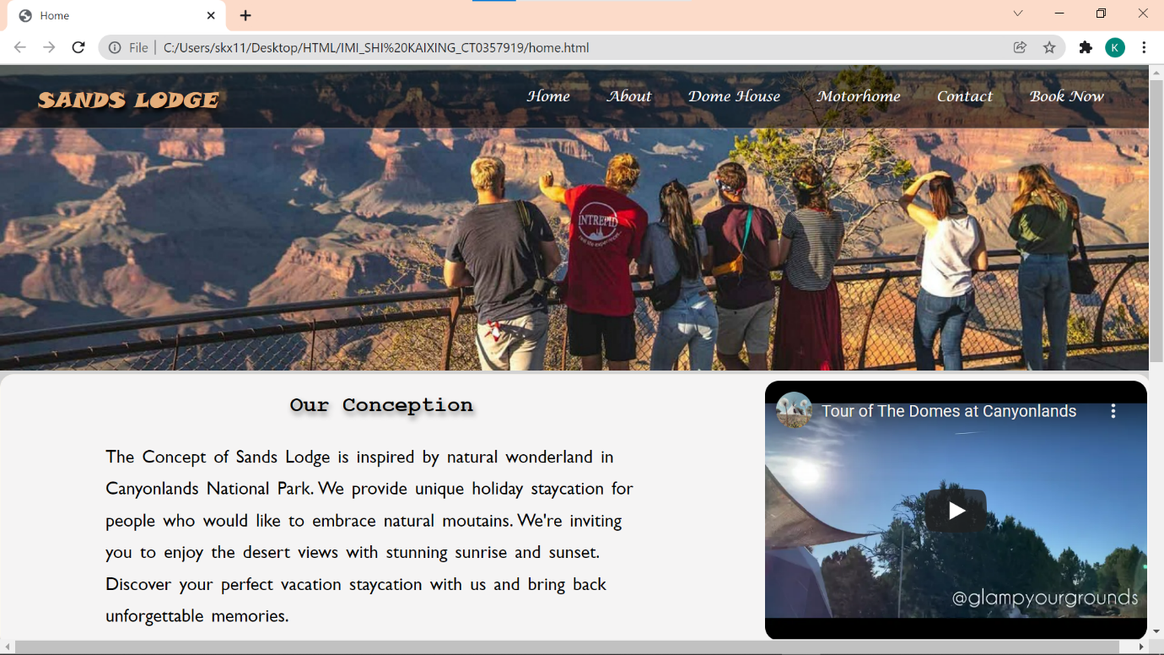

**About Page**

D

|  |  |  |  |
| --- | --- | --- | --- |
|  |  |  |  |
|  |  |  |  |
|  |  |  |  |

Heading

Hyperlink1 Hyperlink2 Hyperlink3 Hyperlink4 Hyperlink5 Hyperlink6

Hyperlink1

Image 1

Heading 1

copyright

Social media icons

Footer

Paragraph 3

Heading 3

Image 3

Image 2

Paragraph 2

Heading 2

Paragraph 1

|  |  |  |
| --- | --- | --- |
| Field | Description | Data Type |
| Heading | Company name | text |
| Hyperlink 1 | Hyperlink to home page | Hyperlink |
| Hyperlink 2 | Hyperlink to about page | Hyperlink |
| Hyperlink 3 | Hyperlink to Dome house page | Hyperlink |
| Hyperlink 4 | Hyperlink to Motorhome page | Hyperlink |
| Hyperlink 5 | Hyperlink to contact page | Hyperlink |
| Hyperlink 6 | Hyperlink to book now page | Hyperlink |
| Image 1 | Picture of company owner | PNG Image |
| Heading 1 | About us | Text |
| Paragraph 1 | Tell more information about us | Text |
| Image 2 | Image of the Motorhome | JPG |
| Heading 2 | Our story | Text |
| Paragraph 2 | share stories about the company | Text |
| Heading 3 | Our services | Text |
| Paragraph 3 | Tell more about our services | Text |
| Image 3 | Image of Dome house | JFIF |
| Footer | Social media icons and copyright . | Icons and text |

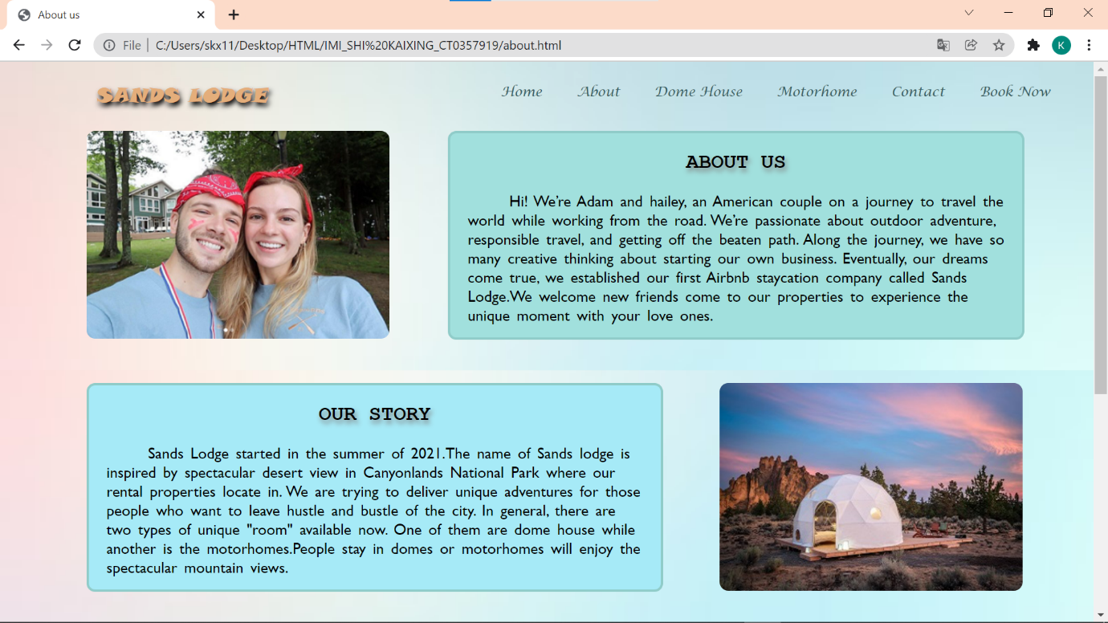

Dome House Page

Hyperlink1 Hyperlink2 Hyperlink3 Hyperlink4 Hyperlink5 Hyperlink6

Heading

copyright

Social media icons

Footer

Image 2

Image 1

Unordered list 2

Paragraph 3

Heading 4

Unordered list 1

Heading 3

Paragraph 2

Heading 2

Image slider

Heading 1

Paragraph 1

|  |  |  |
| --- | --- | --- |
| Field | Description | Data Type |
| Heading | Company name | Text |
| Hyperlink 1 | Hyperlink to home page | Hyperlink |
| Hyperlink 2 | Hyperlink to about page | Hyperlink |
| Hyperlink 3 | Hyperlink to Dome house page | Hyperlink |
| Hyperlink 4 | Hyperlink to Motorhome page | Hyperlink |
| Hyperlink 5 | Hyperlink to contact page | Hyperlink |
| Hyperlink 6 | Hyperlink to book now page | Hyperlink |
| Heading 1 | Name of the property | Text |
| Paragraph 1 | Host name and address of the property | Text |
| Image slider | Auto image slider | JPEG Image |
| Image 1 | Picture of dome house | JPG Image |
| Image 2 | Picture of dome house | JPG Image |
| Heading 2 | About the dome house | Text |
| Paragraph 2 | Describe more information for the room | Text |
| Heading 3 | Things to take note before booking | Text |
| Unordered list 1 | List items for things need to take note | Text |
| Paragraph 3 | Details for things need to take note | Text |
| Heading 4 | What this place offer | Text |
| Unordered list 2 | Several amenities listed | Text |
| Footer | Social media icons and copyright . | Text and icons |

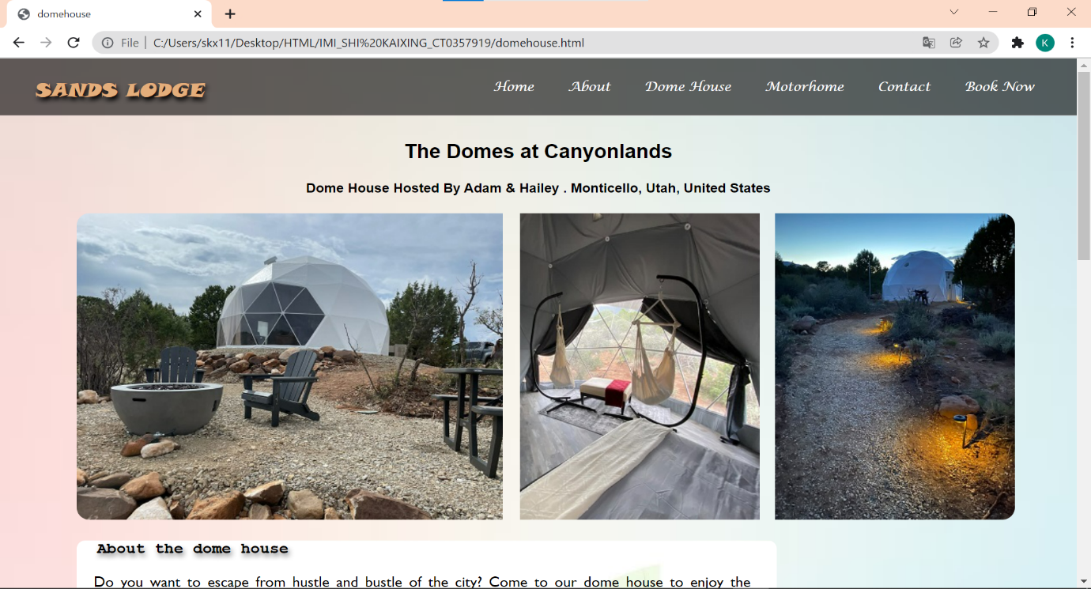

Motorhome Page

copyright

Social media icons

Footer

Unordered list 2

Heading 4

Paragraph 3

Unordered list 1

Heading 3

Paragraph 2

Heading 2

Image 2

Image 1

Image slider

Paragraph 1

Heading 1

Hyperlink1 Hyperlink2 Hyperlink3 Hyperlink4 Hyperlink5 Hyperlink6

Heading

|  |  |  |
| --- | --- | --- |
| Field | Description | Data Type |
| Heading | Company name | Text |
| Hyperlink 1 | Hyperlink to home page | Hyperlink |
| Hyperlink 2 | Hyperlink to about page | Hyperlink |
| Hyperlink 3 | Hyperlink to Dome house page | Hyperlink |
| Hyperlink 4 | Hyperlink to Motorhome page | Hyperlink |
| Hyperlink 5 | Hyperlink to contact page | Hyperlink |
| Hyperlink 6 | Hyperlink to book now page | Hyperlink |
| Heading 1 | Name of the rental room | Text |
| Paragraph 1 | Owner’s name and address of the room | Text |
| Image slider | Five pictures show as image slider | JPEG Image |
| Image 1 | Picture of motorhome | JPG Image |
| Image 2 | Picture of motorhome | JPG Image |
| Heading 2 | About the motorhome | Text |
| Paragraph 2 | Describe more information for the room | Text |
| Heading 3 | Things to take note before booking | Text |
| Unordered list 1 | List items for things need to take note | Text |
| Paragraph 3 | Details for things need to take note | Text |
| Heading 4 | What this place offer | Text |
| Unordered list 2 | Several amenities listed | Text |
| Footer | Social media icons and copyright . | Text and icons |

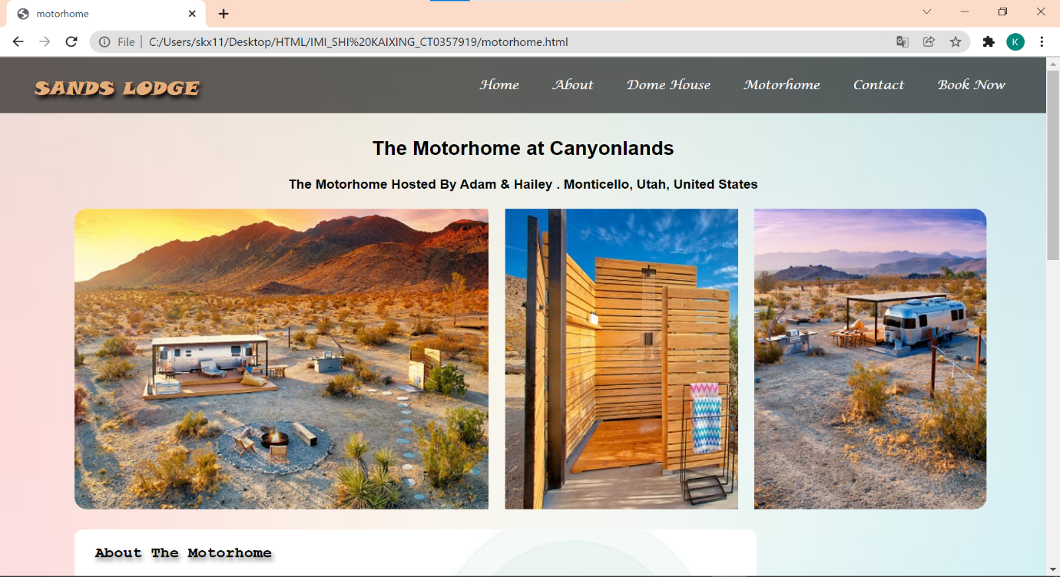

Contact Page

Heading

Hyperlink1 Hyperlink2 Hyperlink3 Hyperlink4 Hyperlink5 Hyperlink6

h

copyright

Social media icons

Button

Your email

Your message

Web Form

Phone number

Your name

Footer

Heading 5

Google map

Heading4

Heading3

Heading2

Heading 1

|  |  |  |
| --- | --- | --- |
| Field | Description | Data Type |
| Heading | Company name | Text |
| Hyperlink 1 | Hyperlink to home page | Hyperlink |
| Hyperlink 2 | Hyperlink to about page | Hyperlink |
| Hyperlink 3 | Hyperlink to Dome house page | Hyperlink |
| Hyperlink 4 | Hyperlink to Motorhome page | Hyperlink |
| Hyperlink 5 | Hyperlink to contact page | Hyperlink |
| Hyperlink 6 | Hyperlink to book now page | Hyperlink |
| Heading 1 | Contact us (marquee) | Text |
| Web Form | Contact form including name ,email  Phone number and message | Text , form |
| Button | Submit Button | Button |
| Heading 2 | Handphone number | Text |
| Heading 3 | Email Address | Text |
| Heading 4 | Address of properties | Text |
| Map | Google map of the Dome house | Google map |
| Heading 5 | Important notes | Text |
| Footer | Social media icons and copyright . | Icons and text |

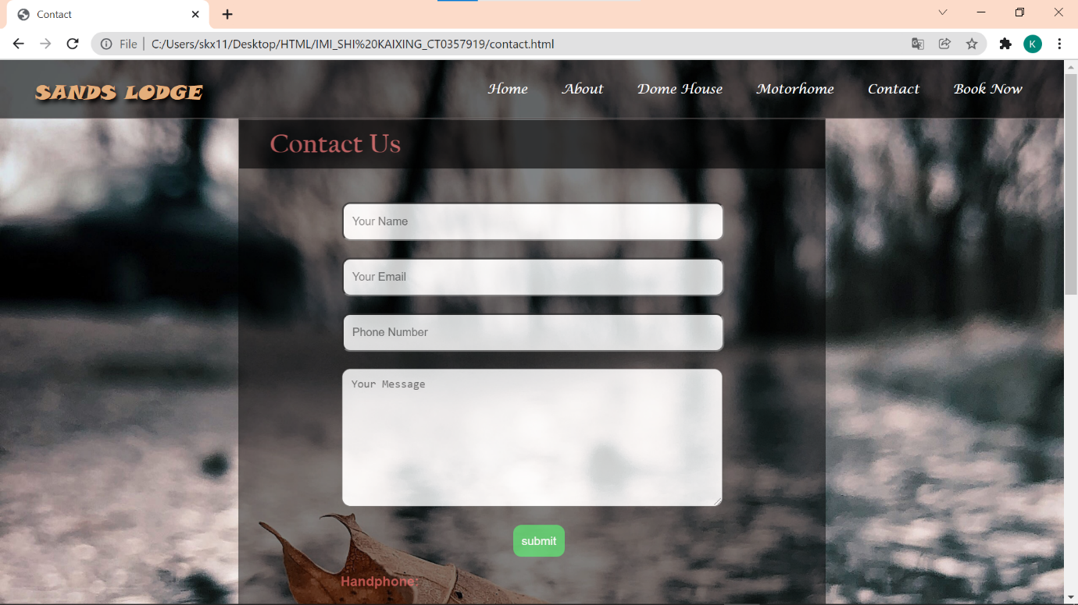

**Book Now Page**

Web Table

Heading 2

Web Form

Button2

Button1

Images

Choose a way to pay

Special request

Pick -up service

Date of check out

Date of check in

Room type

Number of guests

Email

Last name

Contact number

First name

Heading 1

Hyperlink1 Hyperlink2 Hyperlink3 Hyperlink4 Hyperlink5 Hyperlink6

Heading

Footer

Social media icons

copyright

|  |  |  |
| --- | --- | --- |
| Field | Description | Data Type |
| Heading | Company name | Text |
| Hyperlink 1 | Hyperlink to home page | Hyperlink |
| Hyperlink 2 | Hyperlink to about page | Hyperlink |
| Hyperlink 3 | Hyperlink to Dome house page | Hyperlink |
| Hyperlink 4 | Hyperlink to Motorhome page | Hyperlink |
| Hyperlink 5 | Hyperlink to contact page | Hyperlink |
| Hyperlink 6 | Hyperlink to book now page | Hyperlink |
| Heading 1 | Title of registration form | Text |
| Web Form | Details of registration form | Text , Form |
| Images | Images of payment mode | PNG Image |
| Button 1 | Submit button | Button |
| Button 2 | Reset button | Button |
| Heading 2 | Price and information | Text |
| Web Table | Table for price and information | Table |
| Footer | Social media icons and copyright | Icons and text |

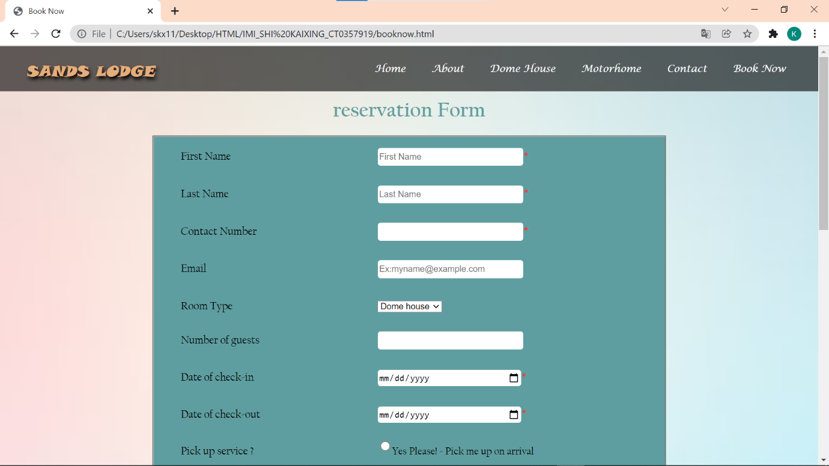

**References**

1. *Walking in Grand Canyon National Park | Intrepid Travel*. (2014). Intrepid Travel. <https://www.intrepidtravel.com/us/united-states/walking-grand-canyon-national-park-137234?gclid=Cj0KCQjw8p2MBhCiARIsADDUFVHDDlIMbIgNvSEFC86yM-Xf4X42GOIpiYX9RlVRogdJzGhBFM5RG4saAiAQEALw_wcB>
2. Y.T. [Glamp Your Grounds ]. (2020, November 8). *Tour of The Domes at Canyonlands* [Video]. YouTube. <https://youtu.be/YnzULdZ9e00>
3. *The domes*. (n.d.). The Domes. <https://www.stayatthedomes.com>/
4. *Wanderlust Airstream*. (2011, August). Airbnb. <https://www.airbnb.com.sg/rooms/44403770?_set_bev_on_new_domain=1635950642_NjUwOGUwNWI5YWEz&source_impression_id=p3_1637121537_oP52%2Fb63W2j3CIV4&guests=1&adults=1>
5. Y.T. [MorningLightMusic]. (2019, August 5). *Upbeat background Music For Videos and Presentations* [Video]. YouTube. <https://youtu.be/SVLXGMfgU5s>